|  |  |  |  |
| --- | --- | --- | --- |
| **Course Name:** | **Elements of Electrical and Electronics Engineering** | **Semester:** | **II** |
| **Date of Performance:** | **06/03/23** | **Batch No:** | **P1 - 2** |
| **Faculty Name:** | **Annu Abraham** | **Roll No:** | **16014022050** |
| **Faculty Sign & Date:** |  | **Grade/Marks:** | **/ 25** |

**Experiment No: 5**

**Title:** **Maximum Power Transfer Theorem**

|  |
| --- |
| **Aim and Objective of the Experiment:** |
| To observe maximum power transfer in D.C. circuit. |

|  |
| --- |
| **COs to be achieved:** |
| **CO1**: Analyze resistive networks excited by DC sources using various network theorems. |

|  |
| --- |
| **Circuit Diagram/ Block Diagram:** |
| **Circuit Diagram: Vs = 50 V and Rs = 560 Ω** |

|  |
| --- |
| **Stepwise-Procedure:** |
| 1. Set D.C. supply voltage V= 50 V. 2. Vary in the range 50 Ω - 10 KΩ in steps of 100 Ω. 3. Note down $I_{L } and V_{L}$ for each value of $R_{L},$ where $I_{L }and V_{L}$ are current through $R_{L}$ and voltage across $R_{L}$ respectively. 4. Prepare observation table showing readings of = 5. Plot graph of 6. Locate the point of maximum value of power $P$ and note down corresponding value of $R_{L}.$ Verify the results theoretically. |

|  |
| --- |
| **Observation Table: Vth = 100V and Rth = 500Ω** |
| |  |  |  |  |  | | --- | --- | --- | --- | --- | | Sr no. | RL Ω | Circuit Current (IL) mA | Circuit Voltage (VL) V | Power absorbed by load (PL) W  PL = VL2/RL | | 1 | 100 | 22.0 | 1.93 | 0.037 | | 2 | 200 | 20.0 | 3.96 | 0.078 | | 3 | 300 | 18.0 | 5.90 | 0.116 | | 4 | 400 | 16.0 | 6.37 | 0.101 | | 5 | 500 | 14.0 | 7.14 | 0.102 | | 6 | 560 | 13.0 | 7.57 | 0.102 | | 7 | 600 | 12.0 | 7.87 | 0.103 | | 8 | 700 | 11.0 | 8.48 | 0.102 | | 9 | 800 | 10.0 | 8.87 | 0.098 | | 10 | 900 | 9.0 | 9.35 | 0.097 | | 11 | 1000 | 9.0 | 9.74 | 0.095 | |

|  |
| --- |
| **Output snap:** |
|  |

|  |
| --- |
| **Graph of PL vs RL:** |
| 300, 0.116 |

|  |
| --- |
| **Calculations:** |
| Let’s take the 4th reading,  VL = 6.37 and RL = 400,  We know, PL = VL2 / RL.  Therefore, substituting values into equation gives,  PL = (6.37)2 / 400 = 0.101 Watts |

|  |
| --- |
| **Conclusion:** |
| In conclusion, maximum power is observed at an added 300 Ω using the rheostat and the value decreases once this value has been achieved.  This can be observed on the graph as well. |

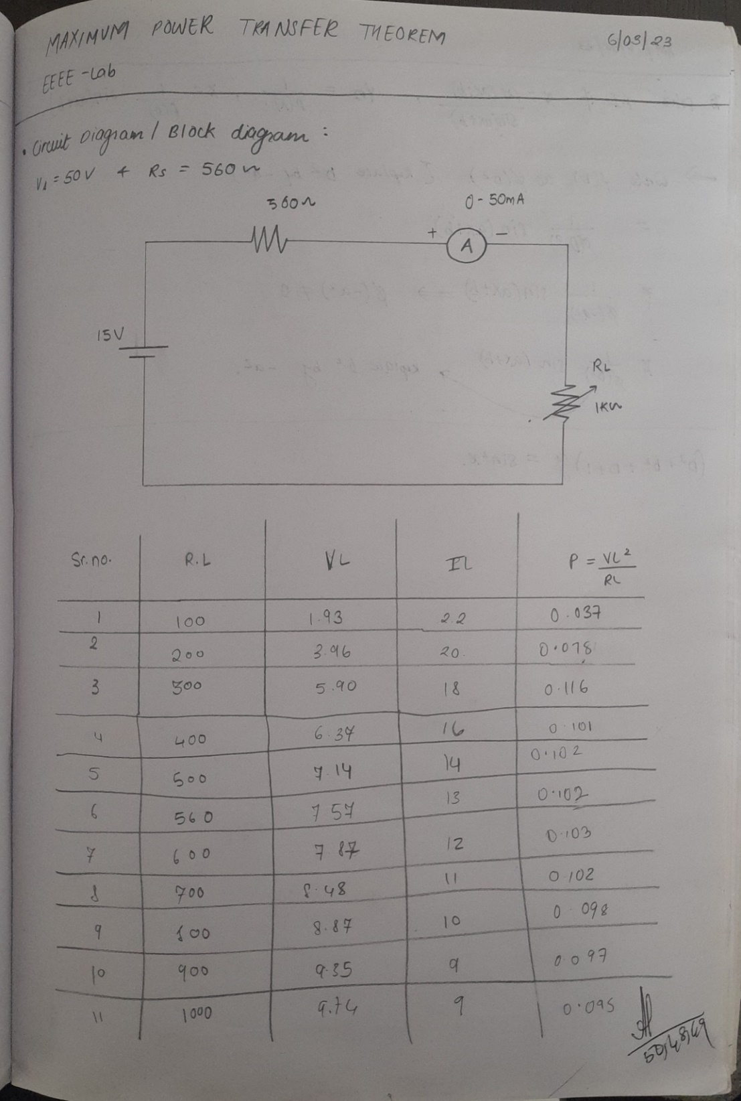

|  |
| --- |
| **Signature of faculty in-charge with Date:** |